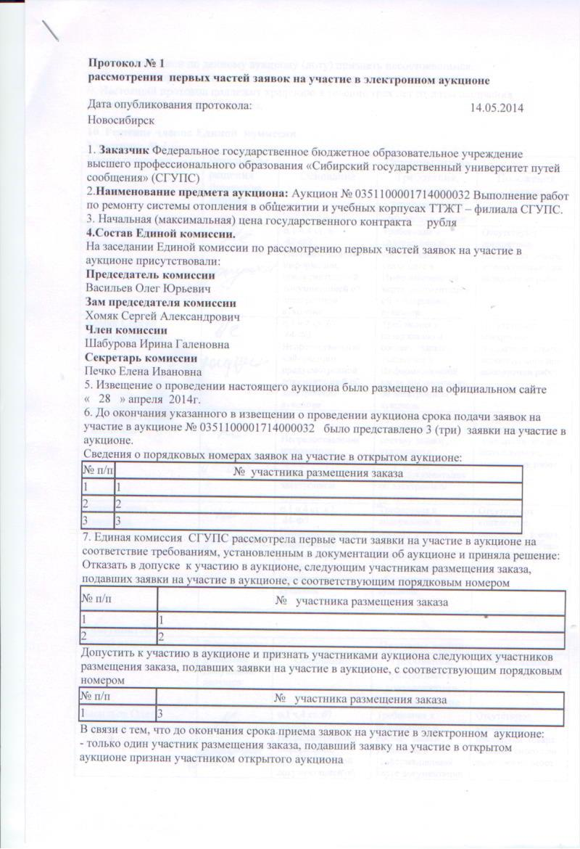D:\User\Documents\My Scans\2014-05-14 2\2.tifD:\User\Documents\My Scans\2014-05-14 3\3.tif